**Báo cáo Lab 1 OOP**

Họ và tên: Lê Nguyên Khải

MSSV: 20225727

Note: Eclipse em cài đặt đang bị lỗi môi trường nên cho em xin phép sử dụng VSCode

Chi tiết lỗi:

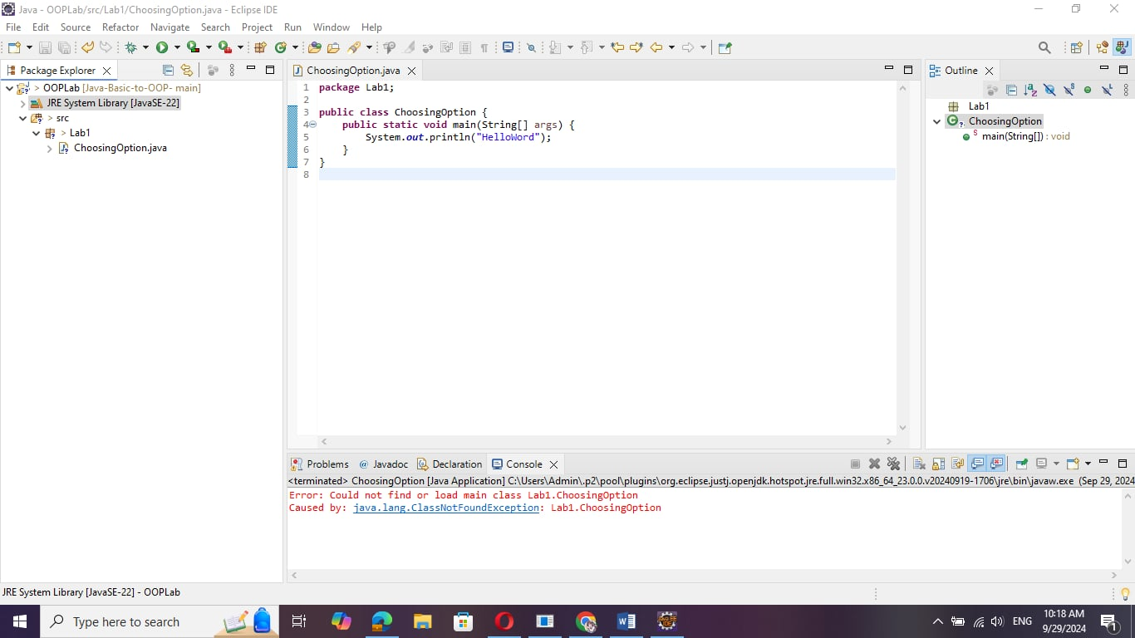

2.2.1 Write, compile the first Java application:

Code:

package lab1;

//Example 1: HelloWorld.java

//Text-printing program.

public class HelloWorld {

    public static void main(String args[]) {

        System.out.println("Le Nguyen Khai - 20225727");

        System.out.println("Xin chao \n cac ban");

        System.out.println("Hello \t World");

    } // end of method main

}

Result:

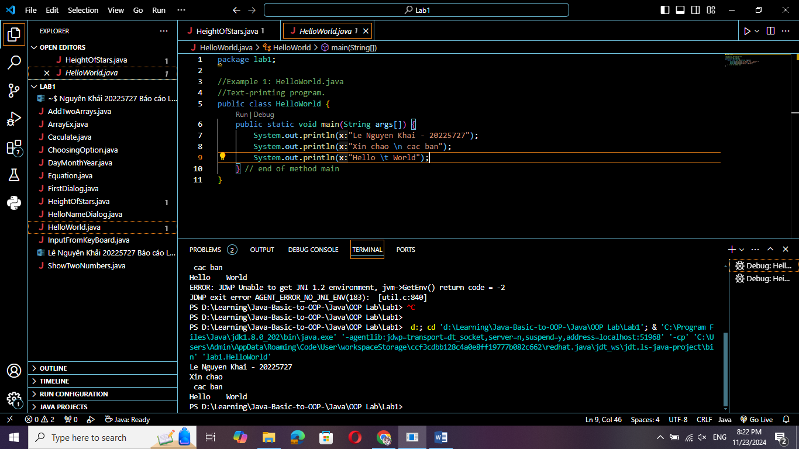

2.2.2 Write, compile the first dialog Java program:

Code:

//Example 2: FirstDialog.java

package lab1;

import javax.swing.JOptionPane;

public class FirstDialog {

    public static void main(String[] args) {

        JOptionPane.showMessageDialog(null, "Hello world! How are you ?");

        System.exit(0);

    }

}

Result:

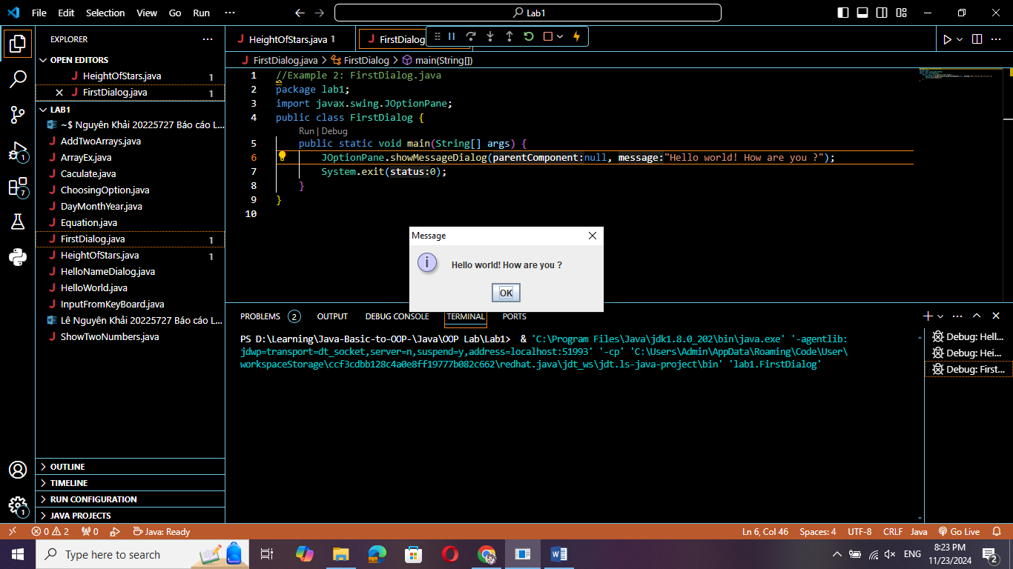

2.2.3 Write, compile the first input dialog Java application:

//Example 3: HelloNameDialog.java

package lab1;

import javax.swing.JOptionPane;

public class HelloNameDialog {

    public static void main(String[] args) {

        String result;

        result = JOptionPane.showInputDialog("Please enter your name:");

        JOptionPane.showMessageDialog(null, "Hi " + result + "!");

        System.exit(0);

    }

}

Result:

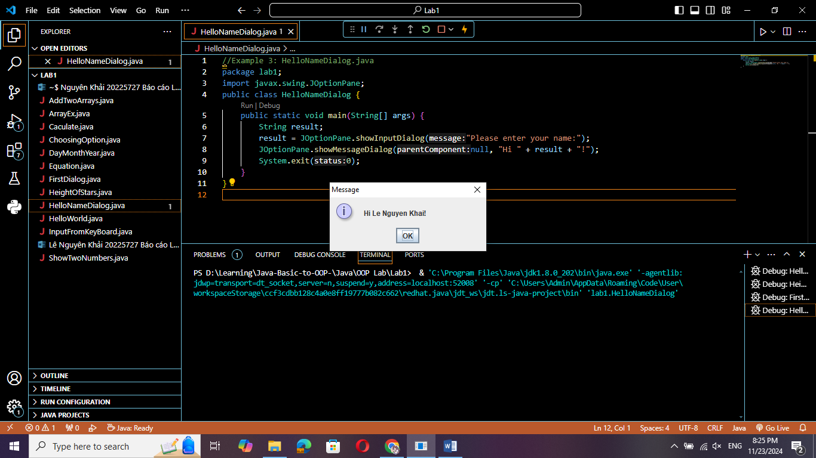

2.2.4 Write, compile, and run the following example:

Code:

//Example 4: ShowTwoNumbers.java

package lab1;

import javax.swing.JOptionPane;

public class ShowTwoNumbers {

    public static void main(String[] args) {

        String strNum1, strNum2;

        String strNotification = "You've just entered: ";

        strNum1 = JOptionPane.showInputDialog(null, "Please input the first number: ", "Input the first number", JOptionPane.INFORMATION_MESSAGE);

        strNotification += strNum1 + " and ";

        strNum2 = JOptionPane.showInputDialog(null, "Please input the second number: ", "Input the second number", JOptionPane.INFORMATION_MESSAGE);

        strNotification += strNum2;

        JOptionPane.showMessageDialog(null, strNotification, "Show two numbers", JOptionPane.INFORMATION_MESSAGE);

        System.exit(0);

    }

}

Result:

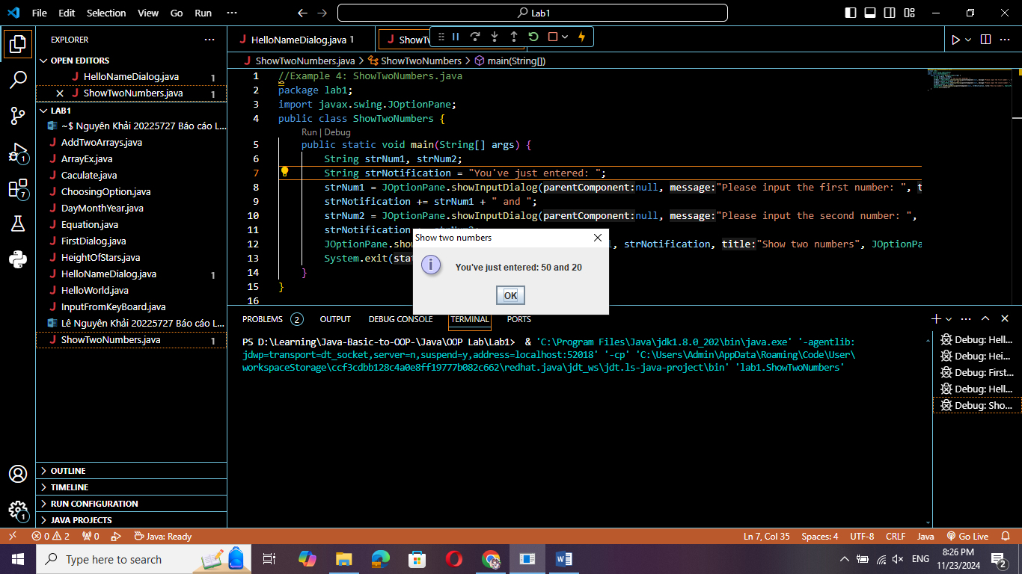

2.2.5 Write a program to calculate sum, difference, product, and quotient of 2 double numbers which are entered by users:

Code:

package lab1;

import java.util.Scanner;

public class Caculate {

    public static void main(String[] args) {

        Scanner input = new Scanner(System.in);

        System.out.print("Enter the first number: ");

        String strNum1 = input.nextLine();

        System.out.print("Enter the second number: ");

        String strNum2 = input.nextLine();

        double num1 = Double.parseDouble(strNum1);

        double num2 = Double.parseDouble(strNum2);

        double sum = num1 + num2;

        double difference = num1 - num2;

        double product = num1 * num2;

        double quotient = num1 / num2;

        System.out.println("Sum: " + sum);

        System.out.println("Difference: " + difference);

        System.out.println("Product: " + product);

        if (num2 == 0) {

            System.out.println("Cannot divide by zero");

            System.exit(0);

        } else {

            System.out.println("Quotient: " + quotient);

        }

        input.close();

    }

}

Result:

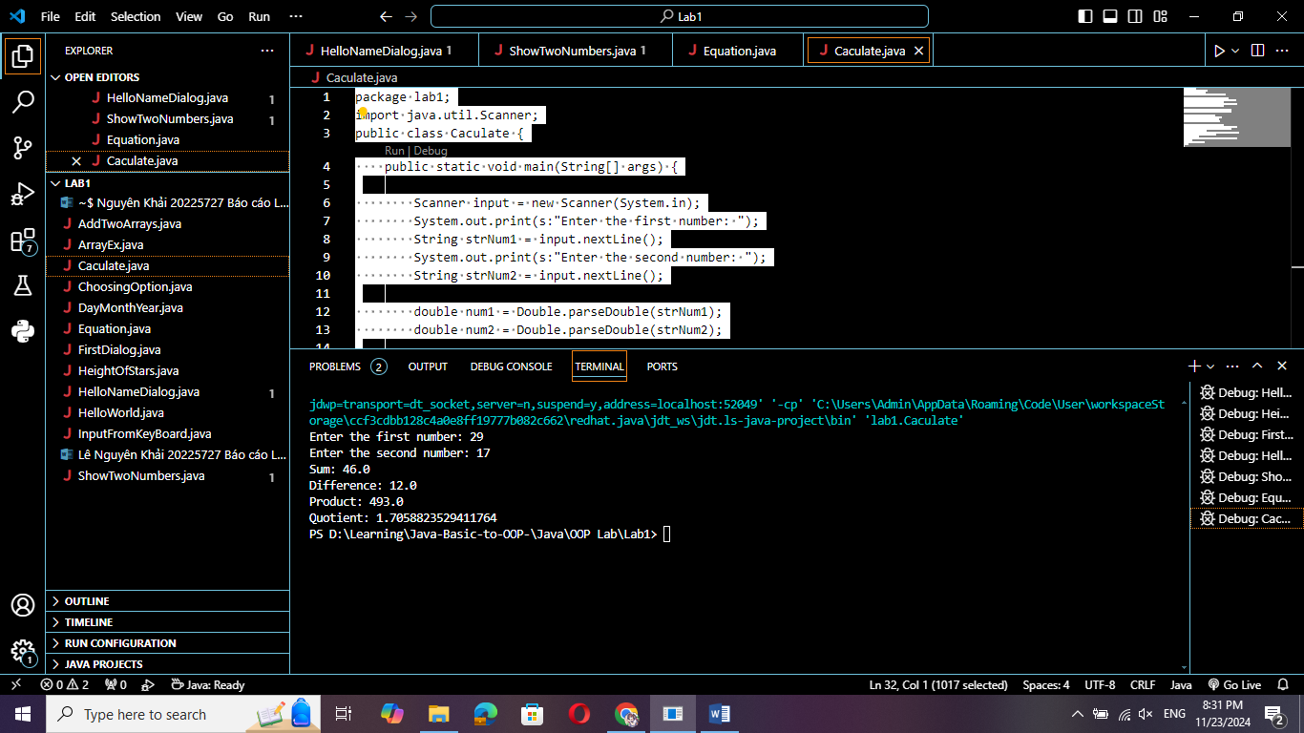

2.2.6 Write a program to solve:

Code:

package lab1;

import java.util.Scanner;

import java.lang.Math;

public class Equation {

    public static void main(String[] args) {

        // Pt1

        Scanner input = new Scanner(System.in);

        System.out.print("Enter a: ");

        Double a = input.nextDouble();

        System.out.print("Enter b: ");

        Double b = input.nextDouble();

        if(a==0) {

            if(b==0) {

                System.out.println("Phuong trinh vo so nghiem");

            } else {

                System.out.println("Phuong trinh vo nghiem");

            }

        }

        System.out.println("Nghiem cua phuong trinh la: " + (0-b)/a);

        // Pt2

        System.out.print("Enter a1: ");

        Double a1 = input.nextDouble();

        System.out.print("Enter b1: ");

        Double b1 = input.nextDouble();

        System.out.print("Enter c1: ");

        Double c1 = input.nextDouble();

        System.out.print("Enter a2: ");

        Double a2 = input.nextDouble();

        System.out.print("Enter b2: ");

        Double b2 = input.nextDouble();

        System.out.print("Enter c2: ");

        Double c2 = input.nextDouble();

        Double d = a1*b2 - a2*b1;

        Double d1 = c1*b2 - c2*b1;

        Double d2 = a1*c2 - a2*c1;

        if(d==0) {

            if(d1 == 0 && d2 == 0) {

                System.out.println("Phuong trinh co vo so nghiem");

            } else {

                System.out.println("Phuong trinh vo nghiem");

            }

        } else {

            System.out.println("Phuong trinh co cap nghiem duy nhat: x1 = " + d1/d + ", x2 = " + d2/d);

        }

        // Pt3

        System.out.print("Enter a: ");

        Double a3 = input.nextDouble();

        System.out.print("Enter b: ");

        Double b3 = input.nextDouble();

        System.out.print("Enter c: ");

        Double c3 = input.nextDouble();

        Double delta = b3*b3 - 4*a3*c3;

        if(a3==0) {

            if(b3==0) {

                if(c3==0) {

                    System.out.println("Phuong trinh co vo so nghiem");

                } else {

                    System.out.println("Phuong trinh vo nghiem");

                }

            } else {

                System.out.println("Phuong trinh co nghiem x = " + -c3/b3);

            }

        } else {

            if(delta<0) {

                System.out.println("Phuong trinh vo nghiem");

            } else if(delta==0) {

                System.out.println("Phuong trinh co nghiem kep x = " + -b3/2*a3);

            } else {

                System.out.println("Phuong trinh co 2 nghiem x1 = " + (-b3-Math.sqrt(delta))/2*a3 + ", x2 = " + (-b3+Math.sqrt(delta))/2*a3);

            }

        }

        input.close();

    }

}

Result:

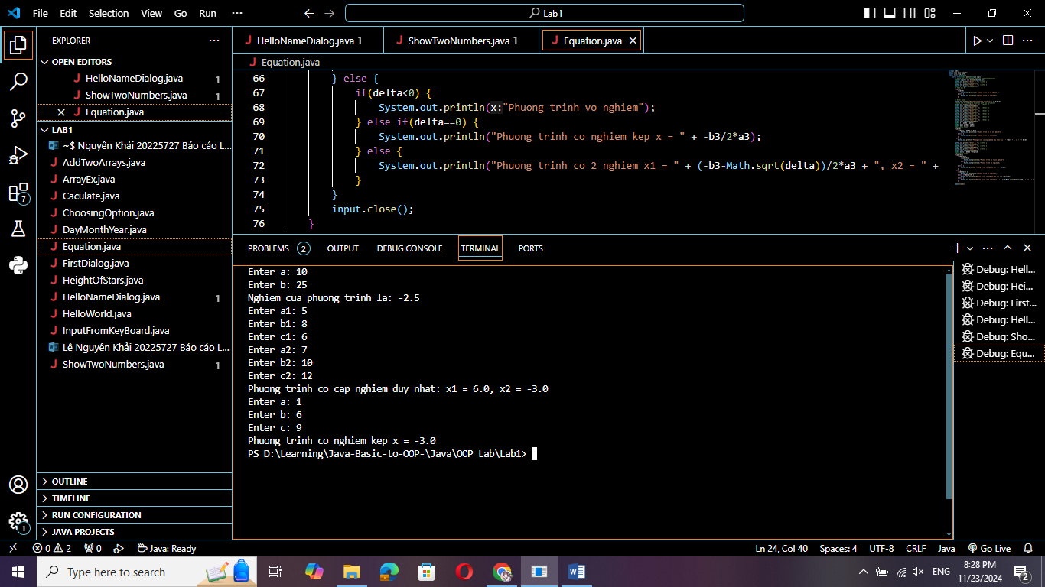

6.1 Write, compile and run the ChoosingOption program:

Code:

package lab1;

import javax.swing.JOptionPane;

class ChoosingOption {

    public static void main(String[] args) {

        int option = JOptionPane.showConfirmDialog(null, "Do you want to change to the first class ticket?");

        JOptionPane.showMessageDialog(null, "You've choosen: " + (option==JOptionPane.YES_OPTION?"YES": "NO"));

        System.exit(0);

    }

}

Result:

* Yes:

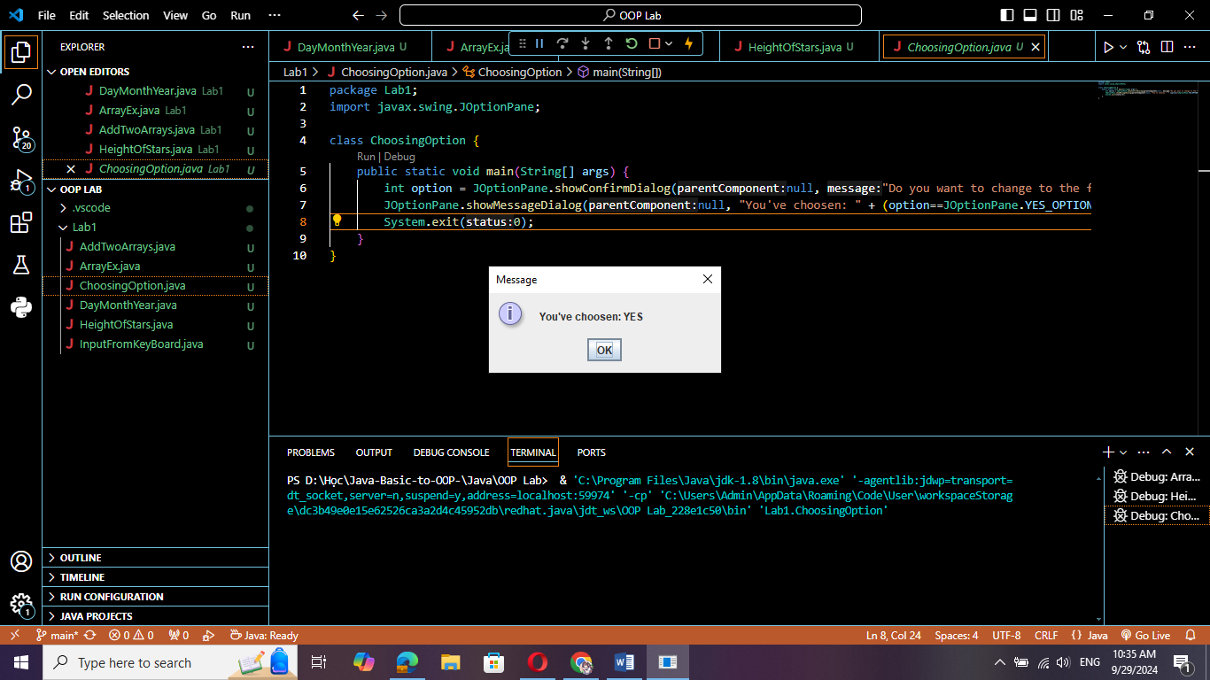

* No:

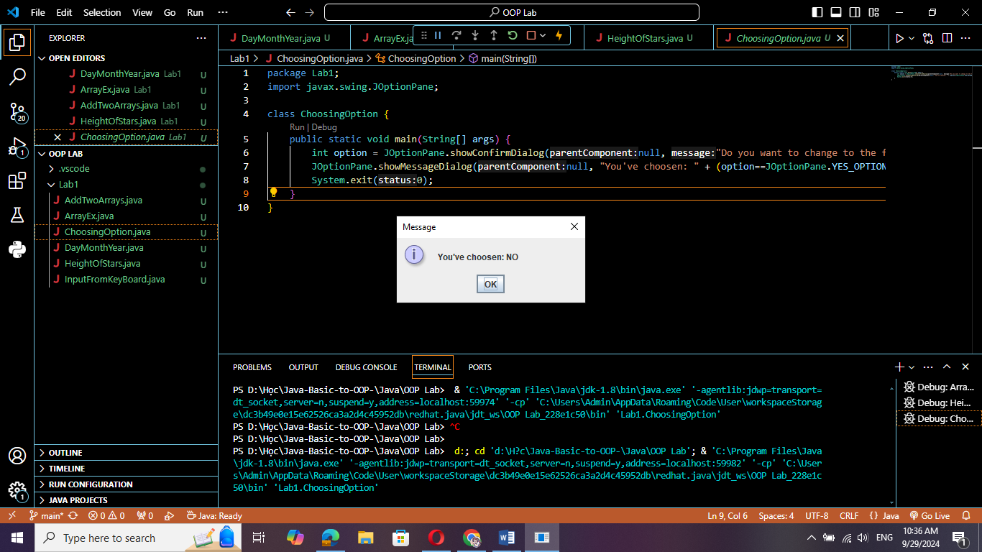

* Cancel:

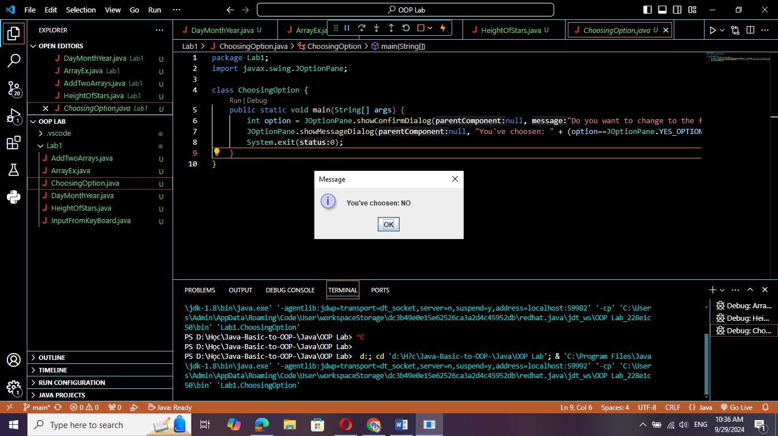

6.2 Write a program for input/output from keyboard:

Code:

package lab1;

import java.util.Scanner;

public class InputFromKeyBoard {

    public static void main(String[] args) {

        Scanner keyboard = new Scanner(System.in);

        System.out.println("What's your name?");

        String strName = keyboard.nextLine();

        System.out.println("How old are you?");

        int iAge = keyboard.nextInt();

        System.out.println("How tall are you (m)?");

        double dHeight = keyboard.nextDouble();

        System.out.println("Mrs/Ms. " + strName + ", " + iAge + " years old. " + "Your height is " + dHeight + ".");

        keyboard.close();

    }

}

Result:

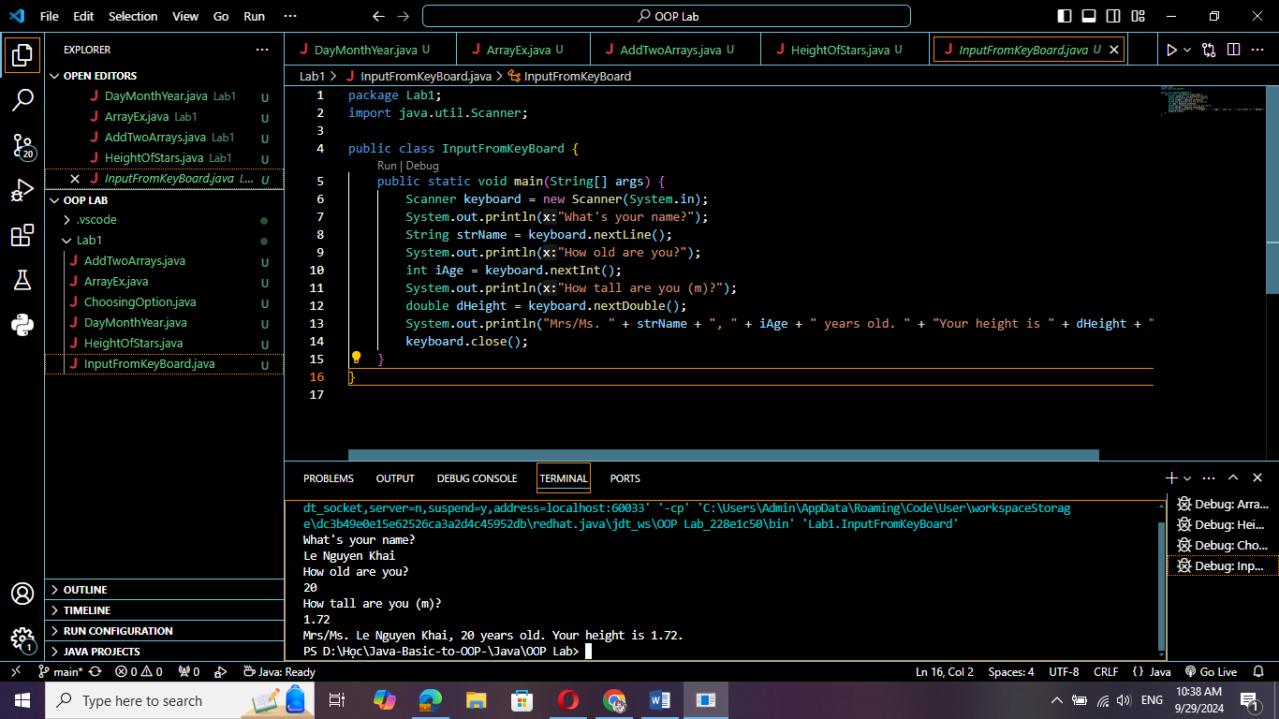

6.3 Write a program to display a triangle with a height of n stars (*), n is entered by users:

Code:

package lab1;

import java.util.Scanner;

public class HeightOfStars {

    public static void main(String[] args) {

        Scanner sHeight = new Scanner(System.in);

        System.out.println("Please input height of stars: ");

        int n = sHeight.nextInt();

            for (int i = 1 ; i <= n; i++){

                for (int j = 1; j < n - i + 1; j++){

                    System.out.print(" ");

                }

                for (int j = n - i + 1; j < n + i; j++){

                    System.out.print("*");

                }

                // for (int j = n + i + 1; j <= n; j++){

                //     System.out.print(" ");

                // }

                System.out.println();

            }

        sHeight.close();

    }

}

Result:

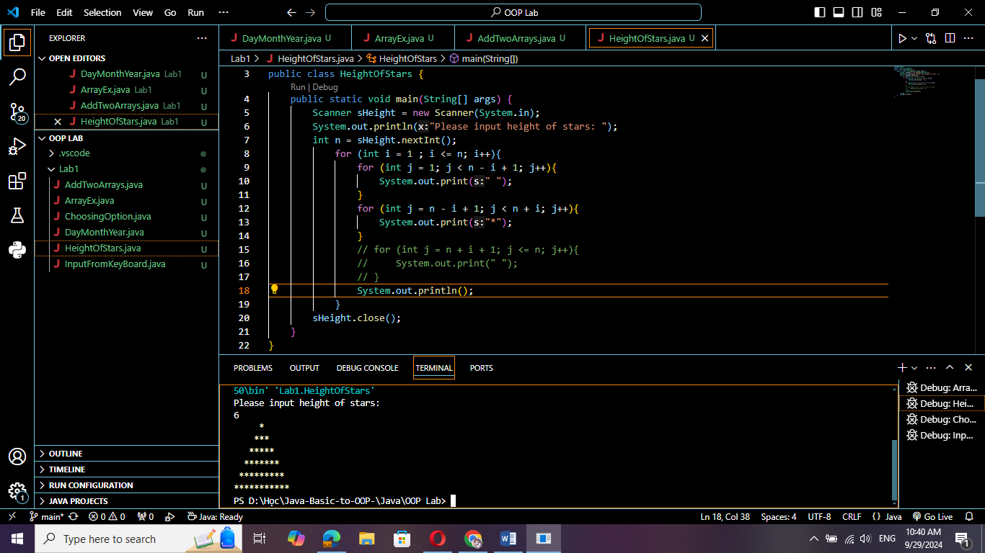

6.4 Write a program to display the number of days of a month, which is entered by users

(both month and year). If it is an invalid month/year, ask the user to enter again.

Code:

package lab1;

import java.util.Scanner;

public class DayMonthYear {

    public static void main(String[] args) {

        Scanner scanner = new Scanner(System.in);

        while (true) {

            System.out.println("Input month: ");

        String Month = scanner.nextLine();

        System.out.println("Input year: ");

        int Year = scanner.nextInt();

        scanner.nextLine();

        int Day = 0;

        switch(Month){

            case "1":

            case "January":

            case "Jan.":

            case "Jan":

                Day = 31;

                Month = "January";

                break;

            case "3":

            case "March":

            case "Mar.":

            case "Mar":

                Day = 31;

                Month = "March";

                break;

            case "5":

            case "May":

                Day = 31;

                Month = "May";

                break;

            case "7":

            case "July":

            case "Jul":

                Day = 31;

                Month = "July";

                break;

            case "8":

            case "August":

            case "Aug.":

            case "Aug":

                Day = 31;

                Month = "August";

                break;

            case "10":

            case "October":

            case "Oct.":

            case "Oct":

                Day = 31;

                Month = "October";

                break;

            case "12":

            case "December":

            case "Dec.":

            case "Dec":

                Day = 31;

                Month = "December";

                break;

            case "4":

            case "April":

            case "Apr.":

            case "Apr":

                Day = 30;

                Month = "April";

                break;

            case "6":

            case "June":

            case "Jun":

                Day = 30;

                Month = "June";

                break;

            case "9":

            case "September":

            case "Sept.":

            case "Sep":

                Day = 30;

                Month = "September";

                break;

            case "11":

            case "November":

            case "Nov.":

            case "Nov":

                Day = 30;

                Month = "November";

                break;

            case "2":

            case "February":

            case "Feb.":

            case "Feb":

            Month = "February";

            if (Year % 400 == 0 || Year % 4 == 0 && Year % 100 != 0){

                Day = 29;

            }

            else {

                Day = 28;

            }

            break;

            default: {

                System.out.println("Invalid Month or Year. Please input again!");

                continue;

            }

        }

        System.out.println(Month + " " + Year + " has " + Day + " days.");

        scanner.close();

        break;

        }

    }

}

Result:

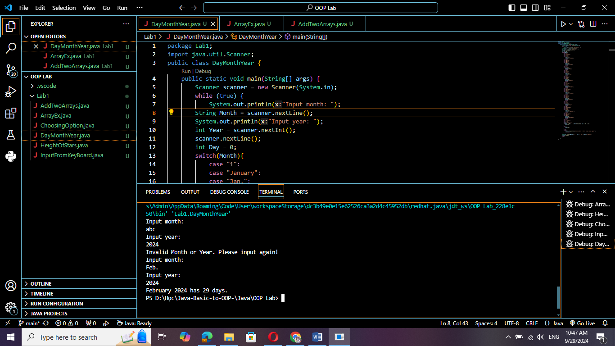

6.5 Write a Java program to sort a numeric array, and calculate the sum and average value of array

elements:

Code:

package lab1;

import java.util.Scanner;

import java.util.Arrays;

public class ArrayEx {

    public static void main(String[] args) {

        Scanner scanner = new Scanner(System.in);

        System.out.println("Nhap so phan tu cua mang: ");

        int n = scanner.nextInt();

        int [] Arr = new int[n];

        System.out.println("Nhap tung phan tu cho mang: ");

        for (int i = 1; i <= n; i++){

            System.out.println("Phan tu thu " + i + ": ");

            int x = scanner.nextInt();

            Arr[i - 1] = x;

        }

        Arrays.sort(Arr);

        int S;

        S = 0;

        for (int i = 0; i < Arr.length; i++){

            S += Arr[i];

        }

        double d = (double) S / n;

        System.out.println("Mang da sap xep: " + Arrays.toString(Arr));

        System.out.println("Tong: " + S);

        System.out.println("Trung binh: " + d);

        scanner.close();

    }

}

Result:

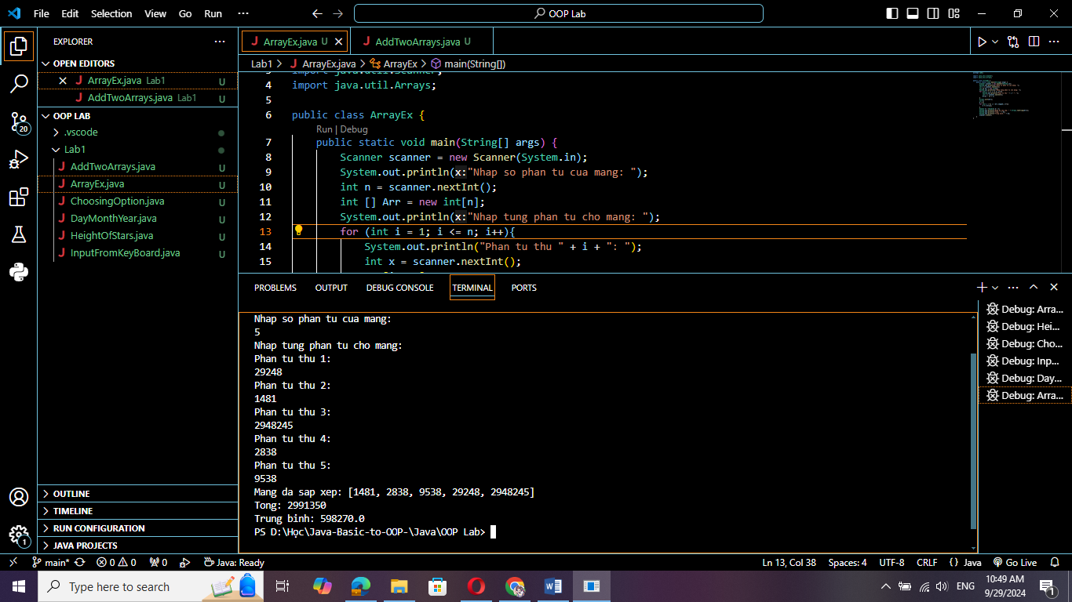

6.6 Write a Java program to add two matrices of the same size:

Code:

package lab1;

import java.util.Scanner;

public class AddTwoArrays {

    public static void main(String[] args) {

        Scanner scanner = new Scanner(System.in);

        System.out.println("Nhap so hang cua ma tran: ");

        int n = scanner.nextInt();

        System.out.println("Nhap so cot cua ma tran: ");

        int m = scanner.nextInt();

        int [][] Arr1 = new int[n][m];

        int [][] Arr2 = new int[n][m];

        int [][] Arr3 = new int[n][m];

        System.out.println("Nhap ma tran thu nhat: ");

        for (int i = 1; i <= n; i++){

            for (int j = 1; j <= m; j++){

                System.out.println("Nhap phan tu hang " + i + " cot " + j + ":");

                int x = scanner.nextInt();

                Arr1[i-1][j-1] = x;

            }

        }

        System.out.println("Nhap ma tran thu hai: ");

        for (int i = 1; i <= n; i++){

            for (int j = 1; j <= m; j++){

                System.out.println("Nhap phan tu hang " + i + " cot " + j + ":");

                int x = scanner.nextInt();

                Arr2[i-1][j-1] = x;

            }

        }

        for (int i = 1; i <= n; i++){

            for (int j = 1; j <= m; j++){

                Arr3[i-1][j-1] = Arr1[i-1][j-1] + Arr2[i-1][j-1];

            }

        }

        System.out.println("Tong hai ma tran: ");

        for (int i = 1; i <= n; i++){

            for (int j = 1; j <= m; j++){

                System.out.print(Arr3[i-1][j-1] + " ");

            }

            System.out.println();

        }

        scanner.close();

    }

}

Result:

